**AlphaBots – Calibrate Camera**

**STEP 1:** copy the following code into folder ~/AlphaPyCharm/FinalVersion1



**STEP 2:** comment/uncomment the following lines of code:

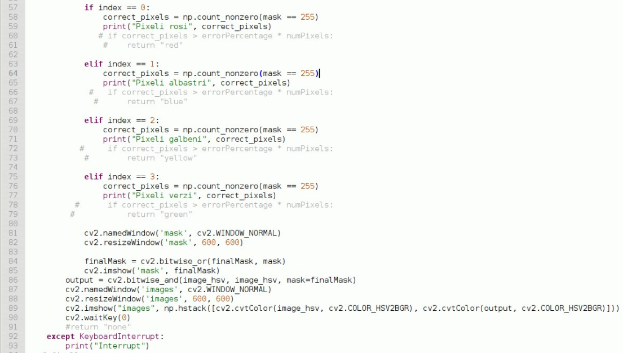

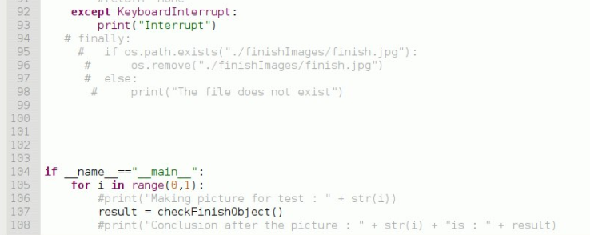

* Change range(0,2) , to range(0,1) -> this means that you want to make only 1 picture

**STEP 3:** run test_camera.py with the following command into the terminal:

* sudo pyhton3 test_camera.py

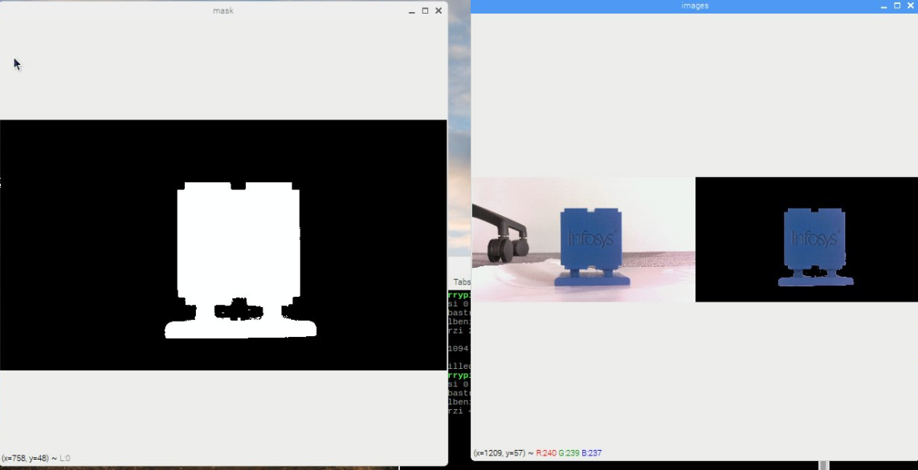

* the picture in the image, is a good result, but sometimes, the white area that you see in the left is not very accurate with the shape of the object.
* In the next step (step 4) you will need to close the process that is open, and from STEP 5 you will start to calibrate the color

**STEP 4:** sometimes, after you run test_camera.py, the process will freeze, just like in the following picture (and when you press ctrl + c , you can’t exit the terminal):

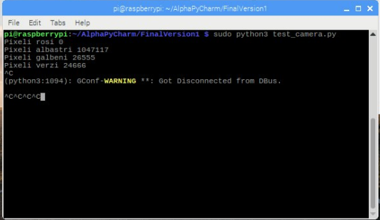

* in this case you have to close the process like in the following image:

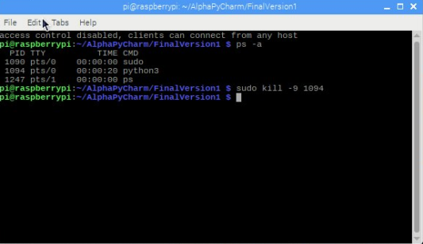

Command : ps –a (this will list all the active process, so you need the id of the process python3 to close it)

Command: sudo kill -9 <your_PS_id>

**STEP 5:**



Run the following command:

* sudo python3 HSV.py

and you will get an output like this:

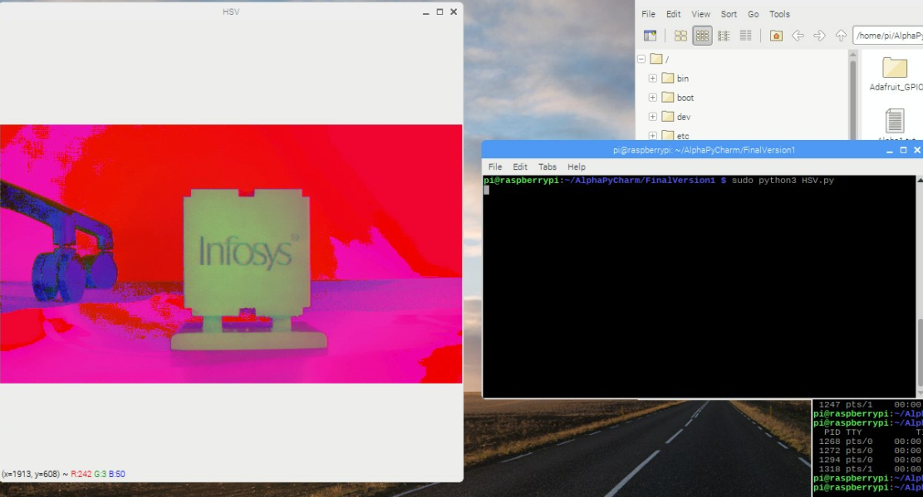

* now you will need to click (with your mouse) in the area where you think, the color is not detected very well

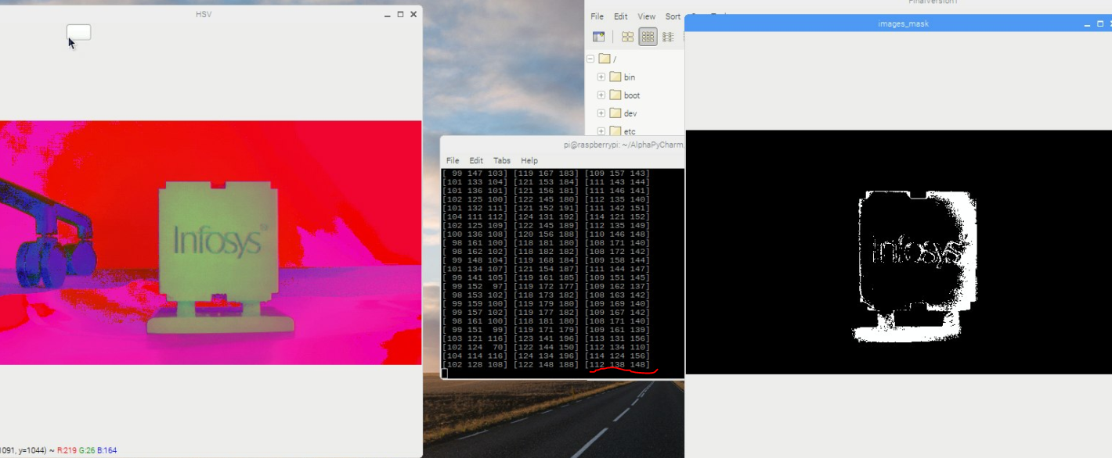

* now you have to note the last vector. In this case, the values are [112, 138, 148]

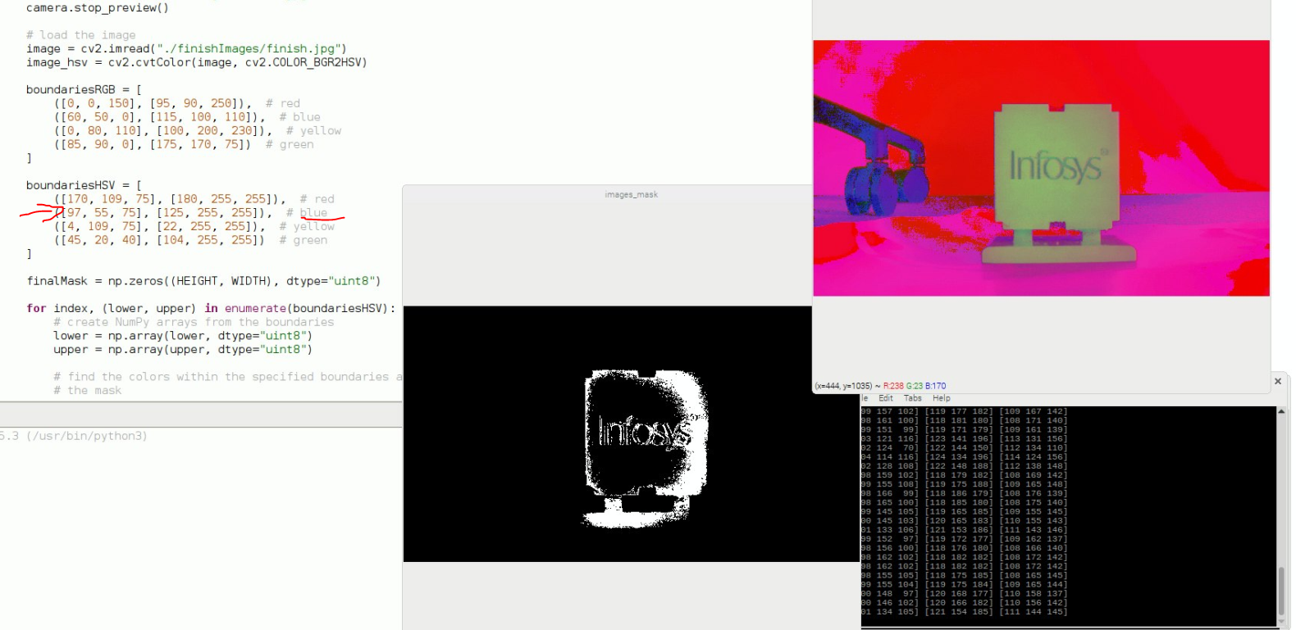

For example, you get [111, 144, 145] in the terminal, and you will need to modify the list with the blue region. The list ([96, 55, 75], [125, 255, 255]) are the min, and max values. So you have to modify the min, and max range values, so that you can integrate [111, 144, 145].

**STEP 6:** modify this lists inside the test_camera.py, and make a new test. If the test will say, that is not blue, repeat the process

**STEP 7:** after you have everything correct, modify your new train values inside the main project script (color_detection.py)